

Name : Benjamin Danish D
Reg No : 192412544
Course name : Advanced Wireless Communication System
Course code : ECA5610
MATLAB Analysis of Spectrum Bands, Propagation Loss and Cellular Interference
Aim:
To compare a simplified free-space path-loss estimate across representative sub-1 GHz, mid-band and mmWave frequencies, and examine how distance and frequency reuse affect received signal and a simple interference measure.
Objectives:
- Calculate or simulate path loss at representative sub-1 GHz, mid-band and mmWave frequencies.
- Compare estimated received signal strength as frequency and distance change.
- Examine how cell separation or frequency reuse changes a simplified interference ratio.
- Relate the results to coverage and spectrum-use considerations across mobile generations, while stating model limitations.
Requirements:
- Computer with MATLAB R2019b or later.
- No RF hardware is required.
Program — Path Loss, Received Power and Reuse Interference
clear;
clc;
close all;

% Representative frequency bands
freqGHz = [0.7 3.5 28];
freqMHz = freqGHz * 1000;
bandName = ["Sub-1 GHz"; "Mid-band"; "mmWave"];

% Link budget parameters
txPowerdBm = 30;
gtDbi = 0;
grDbi = 0;

distanceKm = logspace(log10(0.1), log10(2), 200);
distanceAtPointKm = 0.5;

% Free-space path loss function
fspl = @(fMHz,dKm) 32.44 + 20*log10(fMHz) ...
+ 20*log10(dKm);

% Calculate path loss and received power at 0.5 km
lossAtPoint = fspl(freqMHz, distanceAtPointKm);
rxAtPoint = txPowerdBm + gtDbi + grDbi - lossAtPoint;

linkTable = table(bandName, freqGHz(:), ...
lossAtPoint(:), rxAtPoint(:), ...
'VariableNames', {'Band','Frequency_GHz', ...
'FSPL_dB','EstimatedRx_dBm'});

disp('Path Loss and Received Power at 0.5 km:');
disp(linkTable);

% Plot path loss and received power
figure;
tiledlayout(1,2);

% Free-space path loss
nexttile;
hold on;
grid on;

for k = 1:numel(freqMHz)
plot(distanceKm, fspl(freqMHz(k), distanceKm), ...
'LineWidth', 1.5);
end

set(gca, 'XScale', 'log');
xlabel('Distance (km)');
ylabel('Path Loss (dB)');
legend(bandName, 'Location', 'northwest');
title('Free-Space Path Loss');
hold off;

% Received power
nexttile;
hold on;
grid on;

for k = 1:numel(freqMHz)
rx = txPowerdBm + gtDbi + grDbi ...
- fspl(freqMHz(k), distanceKm);

plot(distanceKm, rx, 'LineWidth', 1.5);
end

set(gca, 'XScale', 'log');
xlabel('Distance (km)');
ylabel('Estimated Received Power (dBm)');
legend(bandName, 'Location', 'southwest');
title('Illustrative Received Power');
hold off;

% Frequency reuse and co-channel interference
cellRadiusKm = 0.5;
reuseN = [1 3 7 12];
pathLossExponent = 3.5;

reuseDistance = sqrt(3*reuseN) * cellRadiusKm;

sirLinear = (reuseDistance/cellRadiusKm) ...
.^pathLossExponent / 6;

sirDb = 10*log10(sirLinear);

% Display reuse results
reuseTable = table(reuseN(:), reuseDistance(:), sirDb(:), ...
'VariableNames', {'ReuseClusterN', ...
'ApproxInterfererDistance_km','ApproxSIR_dB'});

disp('Frequency Reuse and SIR Results:');
disp(reuseTable);

% Plot SIR versus reuse cluster size
figure;
plot(reuseN, sirDb, 'o-', 'LineWidth', 1.5);

grid on;
xlabel('Reuse Cluster Size N');
ylabel('Approximate SIR (dB)');
title('Co-Channel SIR versus Reuse Cluster Size');

% Display received power summary
fprintf('Estimated received powers at %.2f km:\n', ...
distanceAtPointKm);

disp(table(bandName, rxAtPoint(:), ...
'VariableNames', {'Band','Rx_dBm'}));
Simulation Outputs (Free-Space Path Loss and Received Power plots):
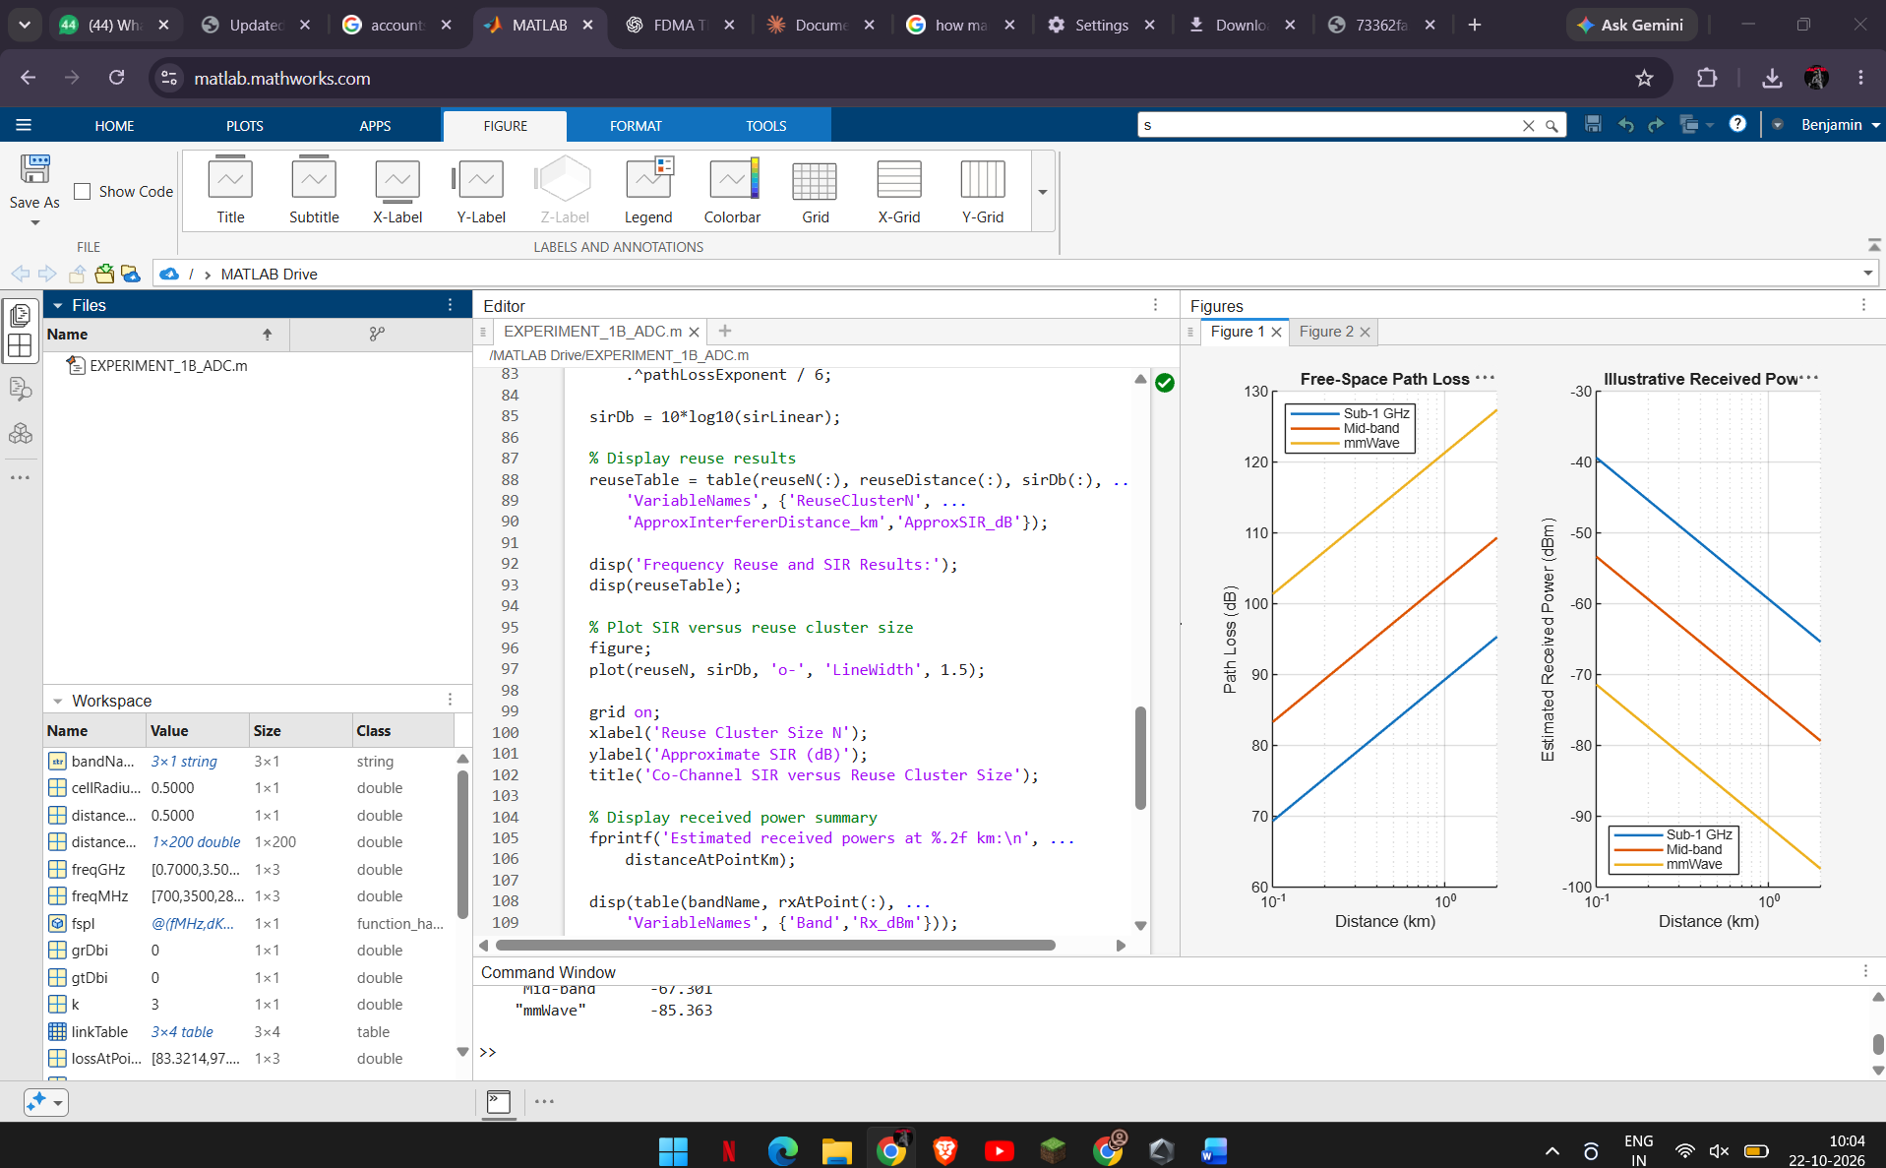
Simulation Outputs (Co-Channel SIR versus Reuse Cluster Size):
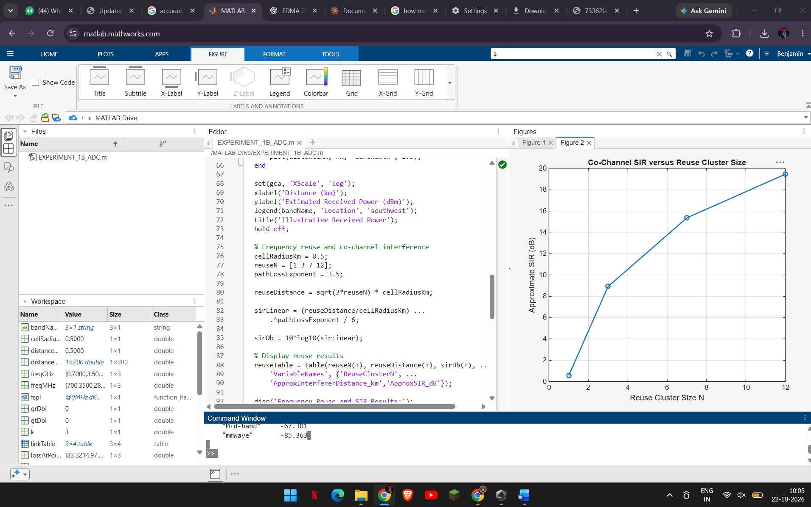
Results to Record:
Band | Frequency (GHz) | FSPL at 0.5 km (dB) | Estimated Rx (dBm)
Sub-1 GHz | 0.7 | 83.321 | -53.321
Mid-band | 3.5 | 97.301 | -67.301
mmWave | 28 | 115.36 | -85.363

Reuse N | Interferer distance (km) | Approx. SIR (dB)
1 | 0.86603 | 0.56811
3 | 1.5 | 8.9177
7 | 2.2913 | 15.357
12 | 3 | 19.454
Analysis Questions:
- At a fixed distance, which representative band has the highest free-space loss? Explain the frequency term in the equation.
- How does doubling distance affect FSPL in this model?
- What trend does the reuse-SIR estimate show as N increases, and which geometric assumption drives that trend?
- Why should the calculated received power not be treated as a reliable coverage radius for an actual cellular system?
- Relate the bands qualitatively to coverage and capacity trade-offs without treating this simple model as a comparison of complete mobile generations.
Conclusion:
Free-space path loss increases with both distance and frequency: at 0.5 km the mmWave band shows the highest loss and the sub-1 GHz band the lowest, and doubling distance or frequency adds about 6 dB. The illustrative SIR rises as the reuse cluster size N increases because the co-channel interferers are placed farther away. The free-space assumption, fixed transmit power and idealized six-interferer geometry are limitations; practical coverage depends on antenna characteristics, environment, bandwidth, receiver sensitivity, interference, regulatory constraints and the chosen propagation model.

